## What is a weighbridge?

A truck weighbridge is a system with different parts that work together to measure the weight of a truck when the truck drives onto the scale.

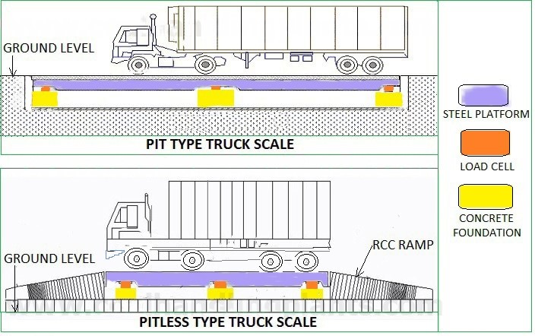

## ****Components of Truck Weighbridge or Truck Scale****

Five main components  for a truck weighbridge or truck scale:

1. Foundation: For permanent installations, it uses a concrete foundation.
2. Steel Platform: This is the surface where trucks drive on.
3. Load Cells: These are crucial components that measure weight. Load cells convert force into an electrical signal for weight measurement.

**[Types and working of load cell](https://www.coalhandlingplants.com/load-cell/)**

## Terminal: Also known as an indicator, the terminal is like the control center for the scale. It shows the weight to the operator and connects to other scale parts.

## Cables: To show the weight on the terminal, the signal from the load cells travels through cables.

## ****How do truck scales work? IMG_256****

The steel platform of the truck weighbridge sits on load cells. Each load cell, usually made of durable materials like steel or concrete, has strain gauges attached. These gauges, consisting of wires transmitting a mild electric current, change when the load cell is pressed due to weight.

As the truck drives onto the weighbridge, these load cells transmit analog signals to a junction box, which combines and sends the summed signal to the weighbridge controller. The controller converts this analog signal to digital using an Analog to Digital Converter (ADC) and displays the weight on an LED screen.

The gross weight, including both the truck and its payload, is measured when the truck is on the weighbridge. To find the net weight (just the payload), the tare weight (weight of the empty truck) is subtracted from the gross weight.

## ****Truck Weighbridge or Truck Scale On-Site Calibration Testing Methods****

****1. Zero Calibration Test****  
 The weighbridge platform, when empty, is adjusted to zero through a process called taring and calibration.

****2. Range Test****  
Calibrating the weighbridge is crucial, and a common practice is to use a weight that is 10% of its total capacity. For instance, a weighbridge with a capacity of 100 tonnes would be calibrated using 10 tonnes of known reference standard test weights.

****3. Repeatability Test****  
Repeatability in the weighbridge system means making sure that it consistently shows the same weight every time you apply a specific calibrated load, regardless of the direction.

****4. Load cell Eccentricity Test****  
To prevent corner errors and ensure accurate weight measurements in a weighbridge, each load cell is tested with a specific weight. The general rule is to use the total weighbridge capacity divided by the number of load cells. For instance, a 60-tonne weighbridge with 6 load cells would be tested with 10-tonne weights on each load cell.

****5. Linearity Test****  
To test the entire weighbridge capacity with reference standard test weights along with dummy loads.